TPM-GL6020 Coefficient Of Friction Tester

User Manual

WUHAN GUOLIANG INSTRUMENT CO., LTD

1、Overview：
Thank you for choosing our company’s testing equipment. Please read this manual carefully before running this equipment, which will help maintain the equipment at a high accuracy and in a good working condition.
Friction coefficient tester is mainly used for test the coefficient friction of plastic film and sheet. It accords with the standard GB10006-88, ISO8295 and ASTM D1894.
Apparatus Outline:
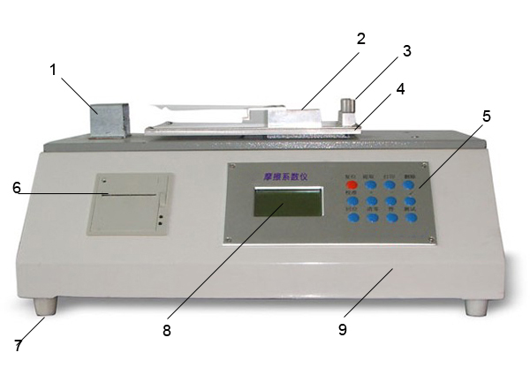
1、Sensor protection cover 2、Slider 3、Clamp
4、Test table 5、Buttons 6、Printer
7、Supporting 8、Screen 9、Box
Working Principle：
The test is used to determine the kinetic (moving) and static (starting) resistance of one surface being dragged across another. A specimen is attached to a sled of specified weight. The sled is pulled across a second surface at a speed of 150 mm/minute. The force to get the sled started (static) and to maintain motion (kinetic) is measured.
Firstly, cut two pieces of specimen, individual 64mm (2.5 in) square specimens along with a 240mm x 127mm (10 x 5 in) second surface. Put one on the test table and hold by the clamp, another one to cover the slider with sided tape.
Test result:
Both static and kinetic coefficient of friction can be calculated. The static coefficient of friction is equal to the initial force scale reading divided by the sled weight. The kinetic coefficient of friction is equal to the average force reading obtained during uniform sliding of the surfaces divided by the sled weight. All measurements are in grams.
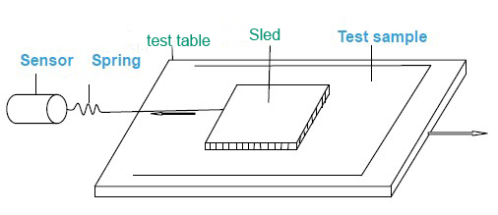
2、Characteristics:
2.1 Main technical parameters
Technical parameters | Specifications
Measuring range | 5 N
Resolution | 0.01N
Accuracy | ±2%
Specimen thickness | ≤0.2 mm
Sled size | 63.5 mm×63.5 mm
Slider mass | 200 g±2g
Test table size | 170 mm×225 mm
Test speed | 150mm/min
Instrument size | About 500 ×335 ×220 mm
Net weight | About 26kg
2.2 Instrument’s working conditions
2.2.1 Room Temperature：20˚C±10˚C Humidity：<85%.
2.2.2 Power Supply：AC110V, 60Hz, Grounded power should be used.
2.2.3 Ensure working environment without strong magnetic field and vibration factors. The working table should be solid and flat.
3、Operation control system:
3.1 Power switch
It is at the back of the instrument.
3.2 Operation button
Operation buttons are shown below：
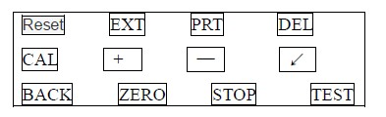
"Reset" button-to initialize the system and to recover when the equipment is malfunctioning
"EXT" button - to display any test data or display a group of test results.
"PRT" button – to print.
"DEL" button - to delete the test results with obvious gross errors.
"CAL" key - used for calibration and adjust calibration line, enter the calibration control system conditions (generally users do not need to use this key).
"+" And "-" key——used to adjust the parameter.
“↙”key—Confirmation key, used to confirm the parameter setting or to enter/exit the test status.
“BACK” button—Used to make test table move to the initial position.
“ZERO” button—Clear the force before test.
“STOP” button—Stop the machine from the test status.
"Test" button – to allow the equipment to do a test run on the full cycle of operation.
Refer to chapter 4 for the specific operating instructions," operation procedures and precautions."
4、Operation procedures and precautions
4.1 Unpacking and installation
4.1.1 Open instrument box.
4.1.2 Remove the bottom bolts fixed on the equipment.
4.1.3 Take out the equipment, clean the dirt (if any) and place the instrument on a flat working table.
4.2 Horizontal adjustment
Ensure this equipment on the horizontal level after put the machine on working table.
4.3 Equipment testing
4.3.1 Connect the equipment with power, and turn on the power switch. The equipment automatically displays “Loading". Upon entering, select the parameter setting interface and run the machine for 30 minutes.
4.3.2 According to 3.2 of operation buttons, check if the equipment can function normally.
4.4、Sled weight setting
Press the “EXT” button on the parameter setting interface to chose “Weight” option, then press the “↙” button to enter the Sled weight setting interface. Use the “+” ,"-" and “EXT” button to adjust the value. After you finish, press the “↙” again to confirm and come back to the parameter setting interface.
Note: The weight of the sled is 1.962N.
4.5、Move distance setting
Press the “EXT“ button to chose “DIS“option then press the “↙“ button to enter the move distance setting interface. Use the "+" ,"-" and “EXT” button to adjust the value. After you finish press the “↙“ again to confirm and come back to the parameter setting interface.
Note: The default move distance is 100mm
4.6、Sample preparation
4.6.1 Sample size
It must prepare two pieces of sample for each test, one is bigger than the bottom of the slider, another bigger than the size of test table.
4.7、Test
4.7.1 Press the “TEST” button to enter the test interface after finish parameter setting.
4.7.2 Press the “BACK” button to make it back to the initial position, if the test table is not in the initial position.
Note：It will back to the initial position automatically if the test table is not in the initial position.
4.7.2 Press the “ZERO” button to clear, if the force value on the screen is not zero when there are no force on the sensor.
4.7.3 Put the bigger sample on the test table and hold by the clamp.
4.7.4 Put another sample on the bottom of the sled, if the sample cannot slide well with the sled, fixed with sided adhesive.
4.7.5 Put the sled on the middle of the test table then use a thread to make the sled link with the sensor. Move the sled to make the thread to unbend.
4.7.6 Press the “Test” button to start the test, the test result will be showed automatically on the screen.
4.7.7 Replace the samples for the next test until a group of test is completed.
NOTE：
If you don't control with the computer a group of test is at most 20. You can press the “RES“ button to reset it.
4.8 Print out
4.8.1 After a group of tests, press "Extract" button to extract any test data of each test, average, standard deviation. (see the meaning of symbol 4.8.4)
4.8.2 After a test, press the "delete" button to delete the data.
4.8.3 After a group of test, press the "Extract" button, find the test data to be deleted, then press "delete" button to delete any test data.
4.8.4 After a group of test, press the "Print" button to print the test data.
The meaning of the symbols as follows:
Parameters
Symbol | Parameters
Sta | kinetic static coefficient friction
Sli | coefficient friction
F | move force value
D | move distance
Sta A | average of static coefficient friction
Sli A | average of kinetic
Sta S | Standard deviation of static
Sli S | Standard deviation of kinetic
…….. | ………

4.9、Related calculation formula
① The coefficient friction is calculated according to the following formula：
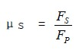
μs—static friction coefficient；FS—static friction force，N； FP—normal force ，N
② coefficient of kinetic friction is calculated according to the following formula：
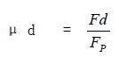
μd—coefficient of kinetic friction； Fd—kinetic friction force，N； Fp—normal force，N；
Because of the weight of the slider is 200±2 g, so Fp=1.96±0.02 N.
5 、Instrument calibration
If you want to calibrate the instrument, please contact with the manufacturer.
6 、 Maintenance
Operators should be familiar with the operating instructions, strictly follow the rules and do the following maintenance tasks:
① keep the equipment clean, cover it with a cloth when the equipment is not used.
② when there is equipment failure, the operator should invite professionals to clean up. Never run the machine with a failure.
③ When the equipment has been running for some time, grease should be deployed to the surface of the lifting units.
④ The equipment should be inspected yearly to keep it in good condition.
⑤ When the paper roll runs out paper should be refilled, the printing paper used is thermal printing paper (size: Φ50mmX57mm).
7、Troubleshooting
7. 1 General mechanical system failure
Symptom | Failure Analysis | Maintenance
No display, buttons not functioning | the fuse burns out, the power switch is damaged, bad or loose power cable. | Replace the fuse, replace the power switch, check and repair the power cord
Malfunctioning display, buttons do not work | system crash | press "Reset" button or turn off the power and then reboot
The printer does not move after pressing the "print" button | 1. a printer off or bad connection 2, Printer is faulty | 1. check the connection 2, replace the printer
Normal display with the key buttons do not work | Button damage | replace the damaged buttons
Test table do not stop while move to the left |  | Change the left microswitch
Test table do not stop while move to the right | The left micro-switch damaged | replace the micro-switch
Normal display with working state failure. | Motor control circuit failure | check circuit, identify the cause of the malfunction and take appropriate measures (professional treatment)

