BGD 954

Temperature Tracker

INSTRUCTION MANUAL



------------------------------------------------------------------------
BIUGED LABORATORY INSTRUMENT (GUANGZHOU) CO,LTD
RM.101,NO.1,DA GUAN ZHONG RD.,DONG PU TOWN.TIANHE DIST.,GUANGHZOU CHINA.
Tel：（86）020-82340366/82341152 Fax：（86）020-82340996 E-mail:carish@biuged.com www.biuged.com

1.0 Technical Specifications and Parameters
One set of BGD 954 furnace temperature tracker contains of a Datalogger, a thermal barrier, a communication cable, thermocouples and software.
This BGD 954 is a four channel digital temperature tracker for Coating with K-type thermocouple as temperature sensor. Temperature indication follows IEC584 temperature/voltage table for K-type thermocouples. It internal memory can keep up to 16,000 records per channel. It uses RS232 interface to perform bi-directional communication with PC.

Numerical Display: 4 digital Liquid Crystal Display per channel.
Measurement Range: -200℃~300℃
Resolution： -200℃~200℃ 0.1℃；200℃~300℃ 1℃
Input Protection at Thermocouple Input: 60V DC, or 24Vrms AC
Sample Intervals: 1s, 2s, 3s, etc
Thermal Barriers Dimensions: 125*110*300mm
Duration: 45min@300℃, or 60min @250℃
Accuracy: ±(0.5% reading + 1℃) at (23±5℃)
Datalogger Dimension: 184×64×30mm
Datalogger Weight: 250g Approx.
K-Type Probe: Patch Probe, Clip Probe and Magnet Probe
Battery Power requirement: 9VDC ±15% 100mA

2.0 Symbol Definition and Button Location:
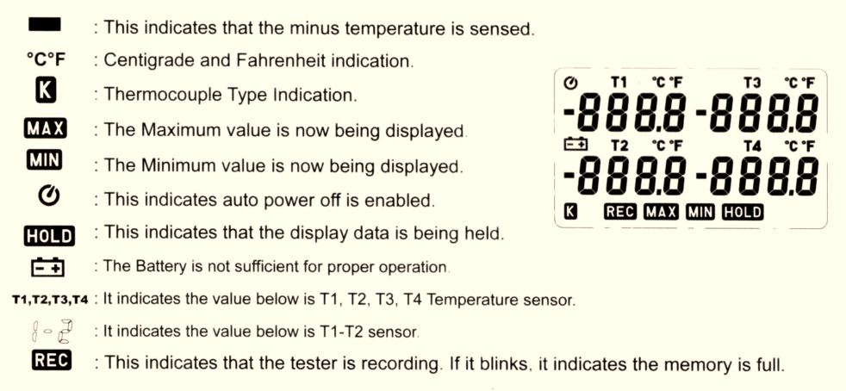

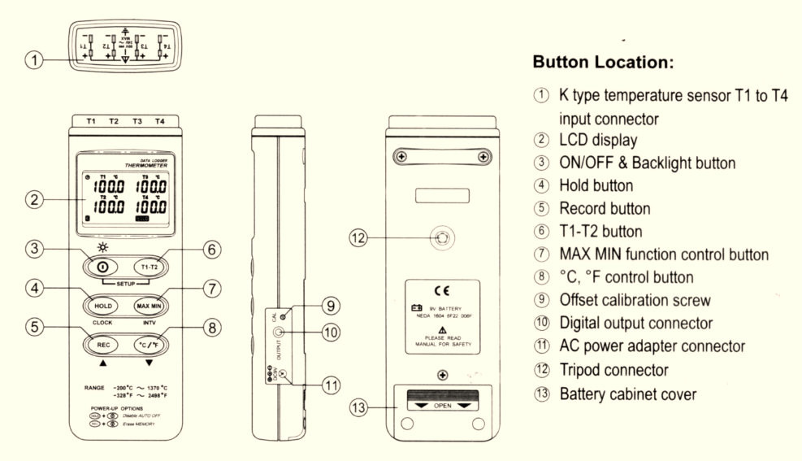

3.0 Operation Instructions:
3.1 Power-Up & Turn ON/OFF backlight
The ① key turns the Thermometer ON or OFF and backlight ON&OFF.
Press it once to turn on the Thermometer.
Press it again for moment to turn ON of OFF backlight.
Press and hold this button 3 second to turn OFF the power.
By default, when the meter is powered on, it is under auto power off mode. The meter will power itself off after 30minutes if no key operation and no RS232 communication combination at power on can disable auto power off.
One may press and hold “HOLD” button and then power on the meter and there will be two successive beeps to indicate that auto power off is disabled and the  will not show up.

3.2 Connection the thermocouples
For measurement, plug the thermocouple into the input connectors.
3.3 Selecting the temperature scale
When the meter was powered on, the user may change it to Fahrenheit ( ℉) by pressing “℃/℉” button and vice versa to Celsius.

3.3 Data-Hold Operation
The user may hold the present reading and keep it on the display by pressing the “HOLD” button. When the held data is no longer needed, one may release the data-hold operation by pressing “HOLD” button again.
When the meter is under Data Hold operation, the “MAX MIN”, “T1-T2”and “℃/℉” button are disabled. (when you press “℃/℉”, “T1/T2”, “MAX MIN” button in HOLD mode, there will be two continuous beeps)

3.4 T1-T2 Operation:
When this button is pushed, ”1-2” will be shown on the upper right hand side LCD display to indicate that the tester is under T1 minus T2 mode. The temperature difference is shown on the right hand side display.

3.5 Record and Erase memory Operation:
When one presses the “REC” button, the meter will start recording, and pressing the “REC” button again will stop recording. If you want to clear the memory, power off the meter, then press and hold “REC” button and then press power button and hold at least 5 seconds, then LCD will show “CLR” “SURE 5”, and then release all buttons to clear the memory.

3.6 Clock Setup:
1: press and hold “T1-T2” button and then power on the meter to enter the setting interface;
2: press “HOLD” (clock);
3: press “REC” ▲ or “℃/℉” ▼ to increase of decrease number, press “HOLD”(clock) to adjust next item. The adjusting order is year →month→day→hour→minute, then press “HOLD”(clock) to finish adjusting. If you want to abort during a setup process, press power button to cancel.

3.7 Recording Interval Setup: the Interval must be set to 1s.
- press and hold “T1-T2” button and then power on the meter to enter the setting interface.;
- press “MAX MIN”(INTV);
- press “REC” ▲ or “℃/℉” ▼ to increase or decrease number. Press “MAX MIN”(INTV) to adjust next item, then press “MAX MIN”(INTV) to finish. If you want to abort during a setup process, press power button to cancel.

3.8 MAX/MIN Operation:
When pressing the “MAX MIN” button the meter will enter the MAX/MIN mode. Under this mode the maximum value, minimum value is kept in the memory simultaneously and updated with every new sample of data.
When the MAX symbol is display, the Maximum is shown on the display.
Press “MAX MIN” again, then the MIN symbol is on the display and also the minimum reading.
Press “MAX MIN” again, MAX, and MIN will blink together. This means, that all these data is updated in the memory and the reading is the present temperature.
One may press “MAX MIN” to circulate the display mode among these options.
When the meter is under “MAXMIN” operation and “℃/℉” button are disabled. (when you press “℃/℉” button in “MAX MIN” mode, there will b e two continuous beep)
To exit the MAX/MIN mode, one may press and hold “MAX MIN” for two seconds.

3.9 Low Battery Condition
When the battery voltage is under proper operation requirement, the 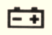 symbol will show on the LCD and the battery needs to be replaced with new one.

3.10 Calibration Point:
input | Adjust VR | tolerance
0 ℃ | VR1 | ±0.1 ℃
190 ℃ | VR2 | ± 0.1 ℃
1000 ℃ | VR3 | ± 1 ℃
P.S: Normally, performing offset Calibration with thermal stabled ice water through VR1 will give a very good calibration result.

3.11 Digital Output:
The Digital Output is a 9600bps N81 serial interface. The RX is a 5Vnormal high input port. The TX is a 5V normal high output port.
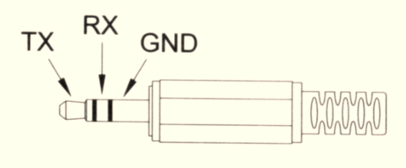

4 .0 Setup TrendtLink BGD 954 ---RS232 interface software:
The TrendLink System Required:
- Windows 98/NT 4.0/ NT200/ XP/ VISTA/Win7
- Minimum Hardware Required:
- PC or Note Book with Pentium 90MHz or higher,32MB RAM;
- At least 5MB byte hard disk space available to install TrendLink.
- Recommended resolution is 1024×768.

Install TrendLink:
- We recommend close all other application before installing TrendLink.
- Insert setup CD disk to CD disk drive.
- Press Setup0.exe to install Tendlink
- The Communication Cable should be set to COM1, COM2, COM3 or COM4.
- Press menu Datalogger → LOAD to download stored Data.
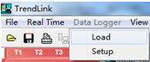
- Press Save stored Data as a file in CSV format.
- Use trendreporter to open CSV file to show the results.

5.0 Data Processing and Analysis of Test Results
After operating data processing software TrendReporter, software operating picture will appear. Open the saved CSV, as the following picture:
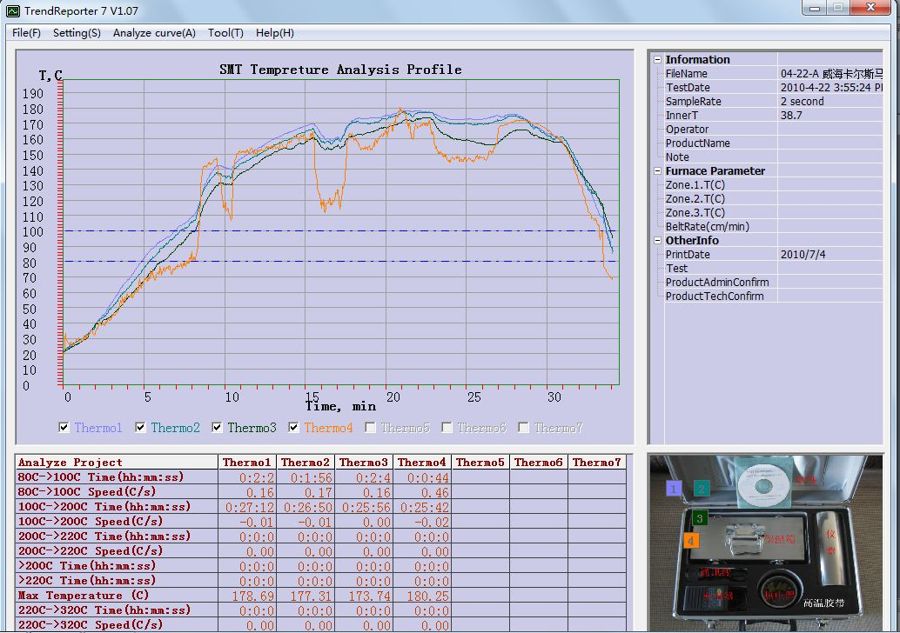
Set relevant parameters of tests in File Information, such as temperature and speed of movement etc. The relevant analysis results will be shown at the bottom of the interface.
In the File menu is mainly save the File and print preview report, print, etc. The default printer must be set when printing the reports.
The menu File mainly contains file saving, reports preview printing and reports printing etc.
Set the following parameters in “Setting”:
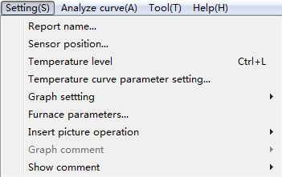
Fig 16 Setting of parameters
Report Name: The name of the test report on the top of geographical area.
Temperature Position: Position of each testing point. It can be modified according to each temperature position.
Temperature Level: Setting values for analyzing temperature level of data. Analyzing data area will calculate automatically after update the temperature level. The Level of T3, T4 and T5 should be less than Max Temperature of this curve.
Graph Setting: Set colors of temperature profiling
Furnace Parameters: Set furnace length and moving speed.
Select “Option”—“Mouse Action Type”：
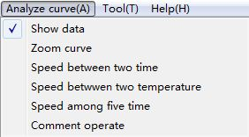
Show Data : Temperature of each point
Zoom Out Curves : Maximize or minimize the curves
Calculate Rate : Calculate temperatures and temperature rates of any time zone.
Limited Warranty
This Temperature Tracker Product is to be used together with the user manual and software. Make sure you have read these manuals and are familiar with the software prior to using your temperature tracker.
BGD Temperature Tracker was warranted against defective materials or workmanship for one year from the date of original purchase. Equipment covered by this warranty will be repaired in China, at the Biuged factory, without charge, except for shipping and handling.
  - Loss or damage to the equipment due to abuse, mishandling accident or failure to follow operating instructions.
  - If the equipment is defective because of water damage.
  - If the equipment has been serviced or modified by other than our authorized agents.
This warranty gives you specific legal rights., and you may also have other rights which wary from state to state. This warranty is given by Biuged Laboratory Instruments (Guangzhou) Co.,Ltd with respect to equipment purchased worldwide. When returning your equipment for warranty service, the shipping charges to BGD must be prepaid. No collect returns will be accepted.
Model:
Serial Number:
Date of delivery:

