BGD 763/1

Closed Paint Mixer/Shaker

INSTRUCTION MANUAL



BIUGED LABORATORY INSTRUMENTS （GUANGZHOU） CO.,LTD
---------------------------------------------------------------------------------------------------------------------------------
Add: RM.101,NO.3, Sicheng Rd., Gaotang Software Park, Tianhe District, Guangzhou.China 510663
Tel：0086-20-32955999 Fax ：0086-20-32955818
E-mail：service@biuged.com Website：www.biuged.com
About Us
Biuged Laboratory Instruments （Guangzhou）Co. Ltd. has been focusing on developing and innovating high-quality and high-precision instruments for 50 years. We are the biggest and most professional manufacturer of testing instruments for paint, coating, ink and printing field in China. All our products are in according with ISO, ASTM, EN standards etc and get CE Certification.
Originally founded in 1963, Biuged have grown to an internationally recognized company with many worldwide customers base which includes the worlds leading paint and coatings manufactures.
At the same time, Biuged has a young, motivate and vibrant team. Our R&D department continually investigates new product design ideas, in conjunction with the major standards committees. In order to supply up to date instrumentation for the Quality Control of coatings, we always apply the advanced contemporary techniques and experience to our new products. Our manufacturing department ensures that all our products are built to the highest quality, every instrument undergoing rigourous calibration and testing before it leaves our premises.
Moreover, Biuged has own independent Calibrate laboratory and more than 40 agents and offices all over the world. We are also the major member of Chinese Standardization Technology Committee of Paint and Pigment.
Produce the highest cost-effective products and offer the most professional service are Biuged mission. Satisfying our customers’ needs are our ultimate wishes.

Factory
Address：No.15,Fuhe Industrial Area, Fuzhong Road, Zhongxin Town, Zengcheng district, Guangzhou City. China
Tel：020-32955999（10line）
Fax：020-32955818
E-mail：carish@biuged.com

Guangzhou office
Address：RM.101,NO.3, Sicheng Rd., Gaotan Software Park, Tianhe District, Guangzhou.China 510663
Tel：020-82169666
Fax：020-82340996
E-mail：andysun@biuged.com

Shanghai office
Address: No.6066, Huqingping Road., Zhujiajiao Town, Qingpu District, Shanghai City, China.
Tel：021-59240298
Fax：021-59249719
E-mail：xjx@biuged.com
1.Summarization:
Many thanks for using our manual clamping paint shaker: this machine is automatic controlled by new style alarm time-setter. When the operation time of the machine reaches the set time, it will stop automatically and the alarm will sound. The machine will stop automatically when the door is opened due to excellent safety and features. Silent operation and added safety. The can is shaking fully at high speed and the highest speed of it is it can mix the paint in 30 minutes, so that highly increase its efficiency and save time.
Our company’s manual clamping paint shaker is easy and convenient to operate, is suitable to all kinds of emulsion and paint mixer.
2. Technique parameter:
*Voltage: 220ACV±10%, 50Hz—60Hz

*Power; 0.75KW

*Mixing range: 0.5-20L
*Equipment keeping environment temperature; -20~50℃
*Using environment, operating temperature: -10~40℃; humidity: 35%－90%（No frost）
*Operation way: continue shake up and down.

*Equipment net weight: 150KG
* Dimension: 850 (L) X 720(W) X 1070(D) MM
3. Use notice:
1) This machine is suitable to mix the non-volatile liquid not the food liquid.
2) This machine must connect to the earth, or will have the danger of shocked by electricity.
3) Only the special technique worker or the people trained can do the work of installation and operation and maintenance.
4) Suitable power: AC210-230V, 50-60Hz (creepage voltage 30ma)
5) Take care of the machine surface to avoid any damage; machine should put on the firm and level place.
6) Cut off the electricity before maintenance and check to avoid any unexpected start operation.
7) Mustn’t leave any tools or sundries inside of the machine.
8) Should assure the function complete of the machine after the maintenance.
9) The installation environment should apply to the local environment (published by the authority department). Don’t pile the paint can around the machine, mustn’t store the tinder inside the machine. Should cut off the power and take out the paint can after work.
10) Should put a “MUSTN’T SMOKE” sign at the 5 meters place aside the machine, mustn’t use the machine within the tindery and explosive environment.
11) Mustn’t operate the machine without any paint can inside the machine.
12) Max mixing weight is 30KG
13) If there is any expected voice, press the emergency bottom to stop the machine and restart the machine again after check and solve the malfunction.
4.Main function:
1) Mixing time can be set from 1-15 minutes
2) Automatically stop when time is up, and will give out a sound of “ Ding” to remind the operator.
3) Safety inter-lock prevents the cabinet door from being opened while the machine is running and it will stop automatically for the door is connected to the electric power.
5.Key button instruction

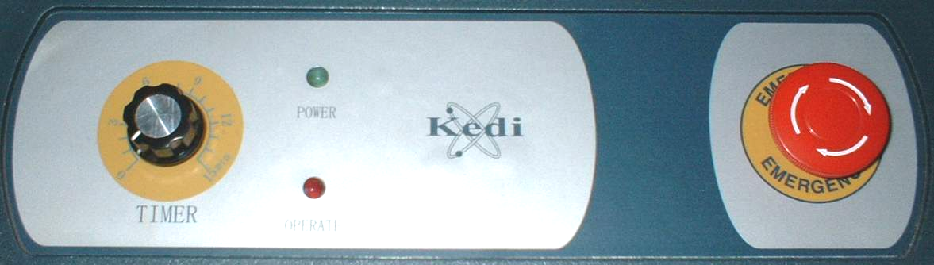
TIMER OPERATE POWER EMERGENCY
1. Time setter (TIMER) can set the time from 1-15 minutes. Increase in the direction of clockwise and decrease in the direction of counter-clockwise.
- Emergency button (EMERGENCY). Press this button to stop the machine when in urgent. Restart the machine according to the instruction of the emergency button.
3. Power indicator light (POWER): the light is on when turn on the electricity, and the machine is in the stand-by condition.
4. Operation indicator light (OPERATE): the light is on when the machine is running ad it will turn off when time is up and the machine will stop.
6. Installation and readjust

(1) Basic requirement: Firm and level concrete ground
(2) Readjust the 4 legs of the machine to make it put on the level place.
(3) Move the machine with suitable tool to avoid overturning the machine.
7. Process and methods of using the machine
- First open the packaging, take the machine out and put it on the firm and level ground (if the ground is not level, readjust the 4 legs of machine to make sure it will work on a level place)
2. Must take off the steel bar first to operate the machine.(Picture A-D)
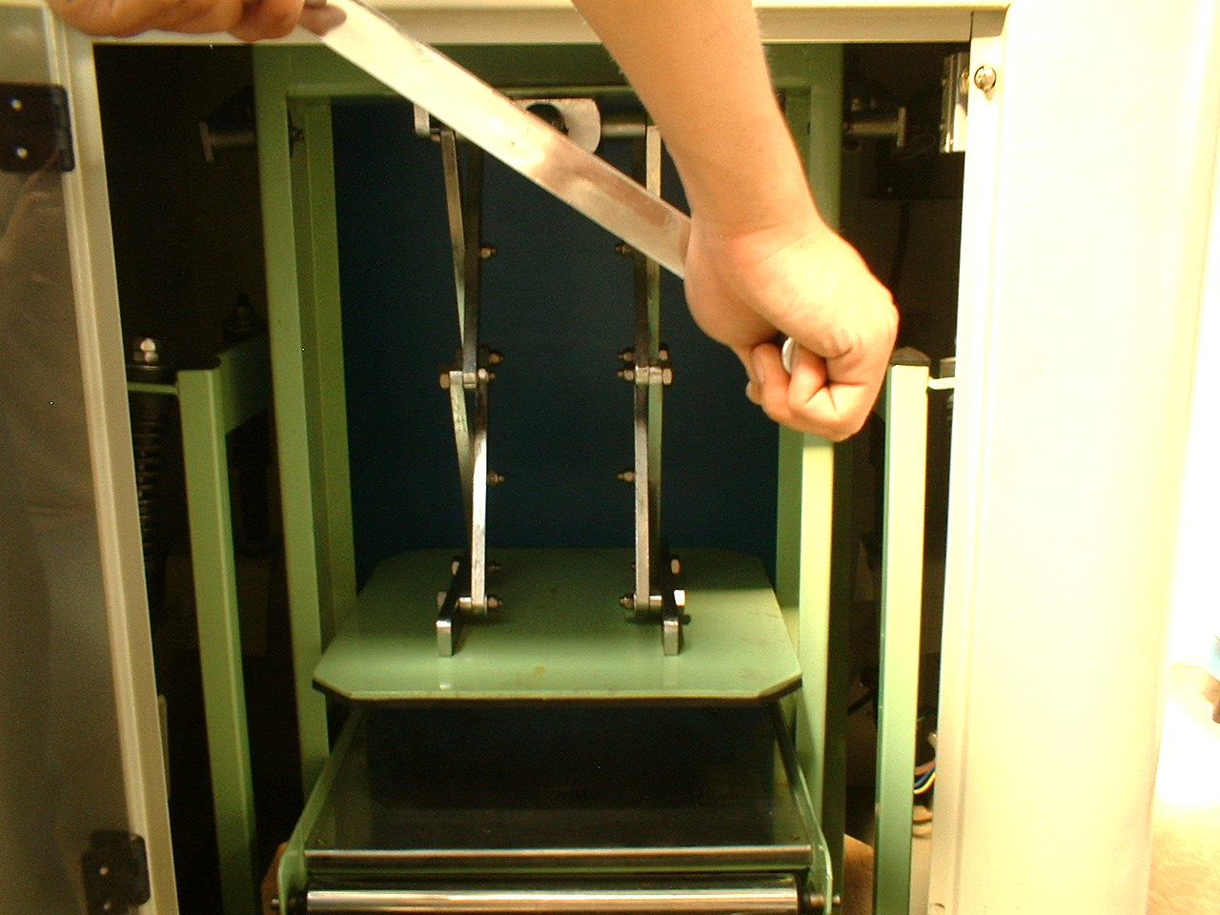 A 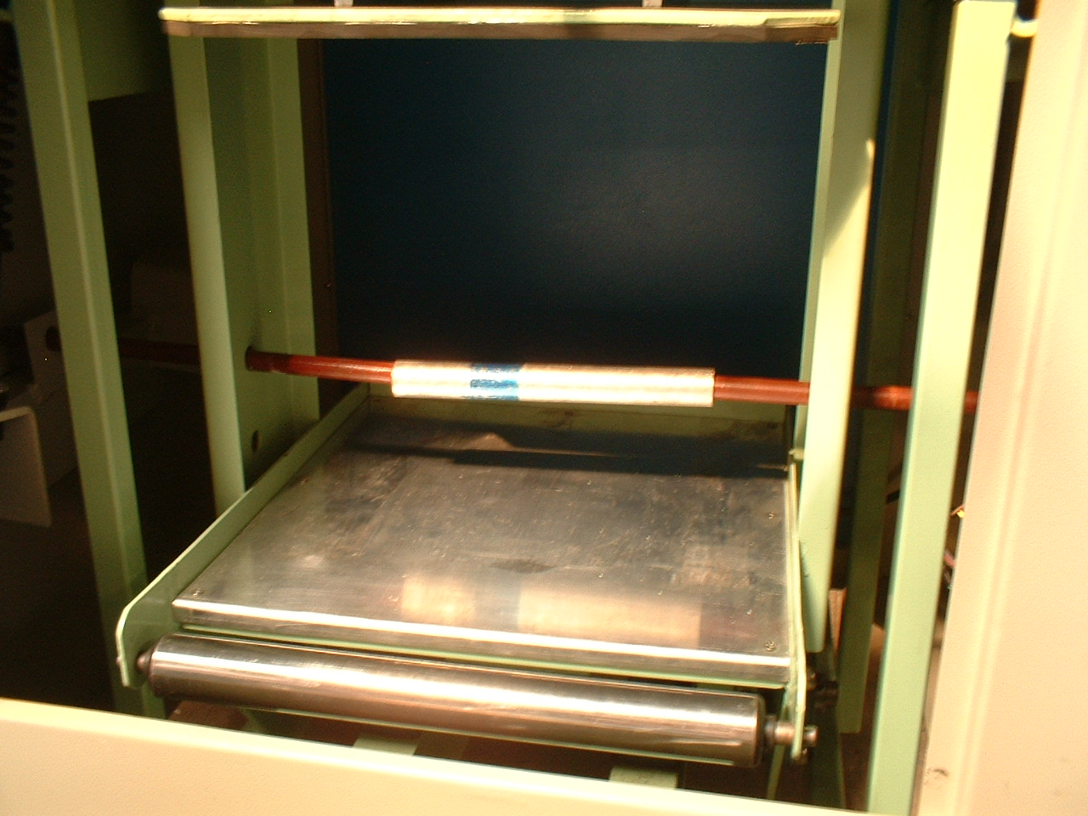 B

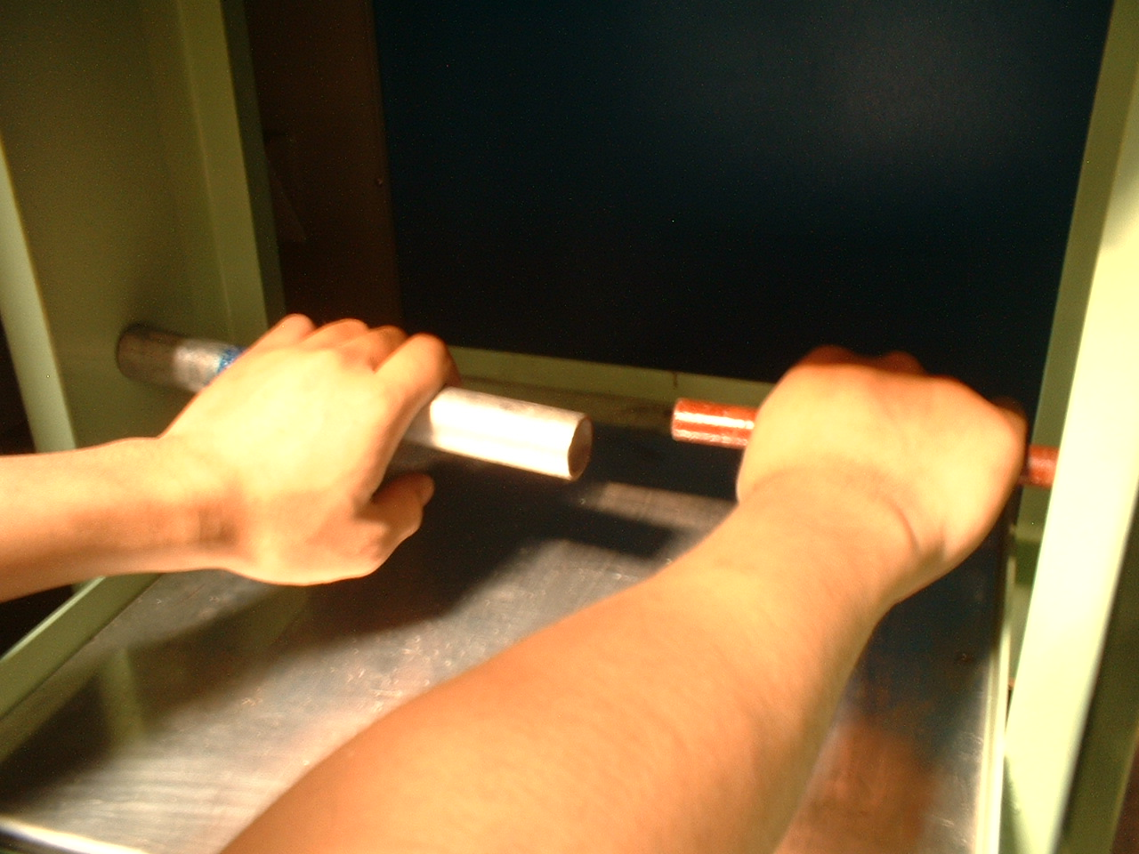 C 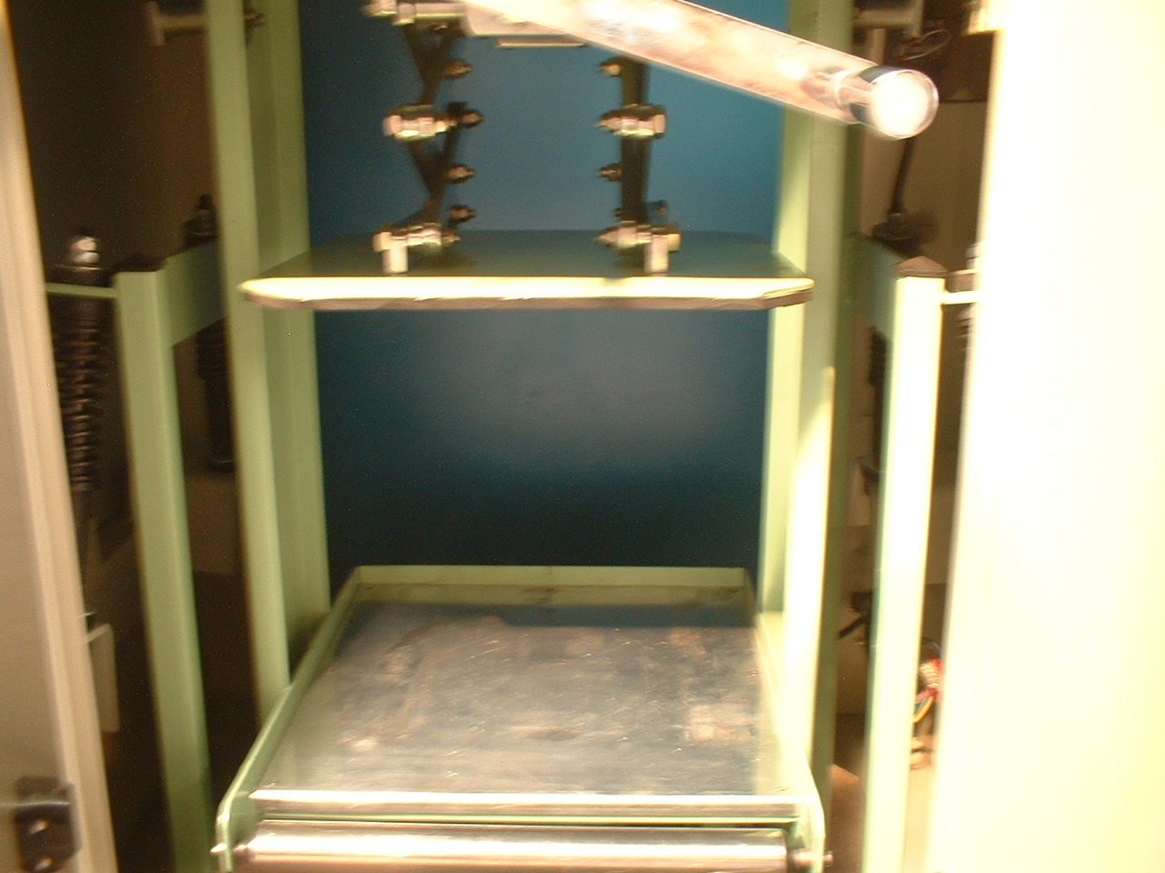 D
A: Turn the hand wheel anticlockwise to raise the clamping board to the max height which is suitable for the big can.
B: Will see a steel bar and sheath when open the clamping board.
C: Knock down the steel bar and sheath.
D: Nothing will be seen in the shaking frame.
E: Push the uphold board with hand gently, it should swing freely
F: Should take off the hand wheel from the shaking frame before connect the machine to the electric power.
G: Insert the electric plug into the AC220V tri-case electric outlet which should connect to the earth.
3.Open the front door and press the paint can cover firm and put it into the machine, turn the hand wheel according to the arrow direction to clamp firm the paint can, and then make firm the screw deasil.
4. Close the front door and reposition the emergency button to start the machine.
5.Turn the TIMER according to your need, and then the machine starts to work. (The longest time can be 15 minutes)
6.Press the EMERGENCY to stop the machine in urgent (Don’t forget to reposition the EMERGENCY to restart the machine next time)
7.There is a safe guiding button at the left side of the front door, the machine will stop when the front door is not close firm or is open during operation.
- When time is due, the TIMER will automatically stop the machine with a sound of “ Ding”. The operator can open the front door at this time and loosen the locknut in the direction of anticlockwise, turn the hand-wheel according to the arrow direction , loosen the press board and then take out of the paint can.
8. Warn sign

Security message
Notice “Security warn sign”
When see the sign of “ Danger, Caution, Notice”, should notice that it may hurt people or damage the machine.
CAUTION: Should notice the potential danger, if cannot prevent, it may hurt the body or got electric shock; it also warn that insecurity operation may forever damage the machine or its function



WARNING: “Mustn’t open the door during its working”, if cannot prevent, it may hurt the people badly.

- Malfunction and solutions.
Reason | Solution
1.The indicator light is not on or the machine is not running. | - Check ht electrical outlet to see whether it has electricity.  - Check to see whether the electric plug does not touch the electrical outlet firm or not  - Check to see whether the electric wire is turnoff or not.
2.The indicator light is not on or the machine is not running. | - Check to see whether the electromotor is burnout.  - Check to see whether the EMERGENCY is reposition or not.  - Check to see whether the TIMER is good or not.  - Check to see whether the plastic door is close firm or not.
3.The machine shakes unusually and has loud voice during operation. | - Check to see whether the paint can is clamped firm.  - Check to see whether the four uphold springs are loose or distorted.
- Matainence.
To assure the usual working, extend the use-life, play its economic value greatly, should do a good daily maintenance. Notice:
  - Only the repair man can knock down this machine
  - Clean the leak paint after use to keep the working platform and pole clean.
  - Lubricate the pole, bearing, springs periodly, and the set the cycle according to your need.
  - Don’t use the acid liquid to clean the floor.
  - Wear the industrial protecting gloves and cut off the electricity before doing the maintenance and check.
11. Transportation and store
1.Should carefully put the machine during transportation and load and unload, mustn’t throw, hit, bump or download, should prevent it from fierce shaken or rain.
2.Should put the machine in the ventilate house at the temperature -10℃~40℃, relative humidity ≤90% and the house should not have any rusty air.
12. Open the packaging and check
1) Should knock down the upper cover before the side cover to avoid scraping the machine surface.
2) Check to see if there are the following things together with the machine:
*Operation manual
*Inspecting report

13 Others
If you want to know more detail information or get a catalog, please visit www.biuged.com or contact with Biuged headquarters or our agents in different regions.

