# MARTINDALE abrasion resistance testing machine

# Operating instruction

Model Number: LX-8826-4



This manual describes the machine settings and technical parameters. Please keep them in a safe place. Please read the instructions carefully before use.

**Contents**

1. Introduction

2. The main technical parameters

3. Instrument icon

4. Instructions for use

5. Operation method

6. Rating

7. Maintenance and Maintenance

Quality Assurance

Nine warranty card

**1. Brief description**

The instrument is designed to absorb the advantages of similar instruments at home and abroad. Its elegant appearance and easy operation make the microcomputer system use two kinds of counting methods, intuitive and generous, easy to set up, and four stations at the same time to improve the test efficiency. The instrument also has two kinds of Lissajous 24mm×24mm, 60.5mm×60.5mm motion trajectories and various accessory attachments, which can adapt to various test method standards.

The instrument is suitable for: GB/T4802.2, ASTM D4970, ISO12945-2 and other fabrics pilling test. The principle: the circular sample and the same material fabric under a given pressure, with Lissajous figure motion trajectory friction, to achieve the required number of rotation, the evaluation of the sample pilling level. Also suitable for GB/T13775, ASTM D4966, ISO12947 fabric abrasion resistance test. The principle is that the circular fabric sample rubs against the standard abrasive according to the trajectory of the Lissajous curve under a certain pressure, causing the sample to break. The wear resistance of the sample is used to indicate the wear resistance of the fabric. performance.

Standards compliant:

In line with: GB/T4802.2, ASTM D4970, ISO12945-2 and other fabrics pilling degree test.

Also meet: GB/T13775, ASTM D4966, ISO12947-3-1998 fabric abrasion resistance test.

**2. The main technical parameters**

Workstation 4

Count display a. Estimated count: 0～999999 times

b. Accumulated count: 0～999999 times

The maximum stroke range is 24±0.5mm and 60.5±0.5mm

Pressurized mass a. Clamp: 200±1g

b. cloth sample weight : 395±2g

c. furniture accessories sample weight: 594±2g

d. Stainless steel butterfly 260±1g

Abrasive block effective friction diameter Type A 200g (1.96N) friction head ¢ 28.8 -0.084mm

Type B 155g(1.52N) friction head ¢ 90 -0.10mm

Gripper and grinding table relative movement speed 50-2r/min

Loading sample weight 2385±10g

Dimensions 885×600×410mm (L×W×H)

Weight 150kg

Power Ac220V 50Hz

**3.Product Image**

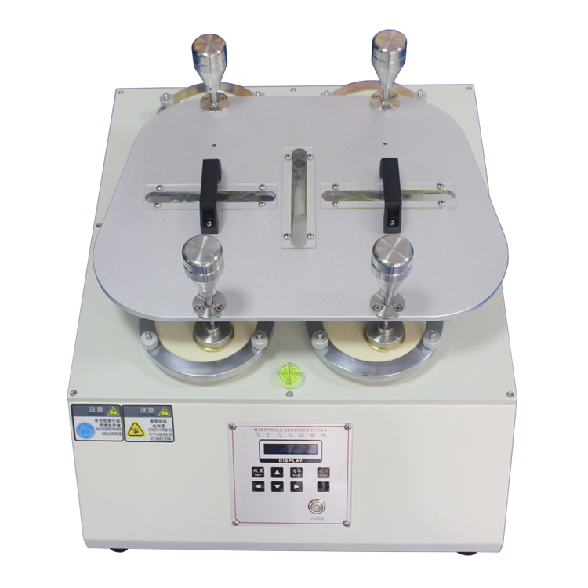

**4. Instructions for use**

1 Scope

1.1 Suitable for judging fabric pilling and other surface wear-related changes

1.2 This method is applicable to all kinds of knitted fabrics, leather and woven fabrics

1.3 not suitable for thickness 3mm fabric

1.4 also applies to samples after washing or dry cleaning

2. Principle

2.1 The sample is mounted on a Martindale wear tester, running a fixed number of revolutions

2.2 The friction specimens were rated with a standard map light under a standard light source.

3. Equipment and standard materials

3.1 Martindale wear resistance instrument

3.2 Standard felt: gram weight 750±50g/m2, thickness 3±0.3mm

3.3 Standard friction fabric combed plain fabric made of wool Weight 195 g/m2

3.4 standard foam lining: density 29 ~ 31kg/m2, thickness 3 ± 0.01mm

3.5 Rating Chart: A group of pictures arranged by "very serious pilling" to "not pilled" to show the degree of pilling.

3.6 fabric scissors: diameter of 38mm, 140mm.

3.7 rating box: cool white fluorescent light source

4. Sample preparation

4.1 Unless otherwise specified, samples shall be washed and dry cleaned before taking the sample according to the end use of the fabric.

4.2 The position of the sample must be more than 1/10 of the width of the entire cloth from the edge and distance

4.3 Do not sample areas of weaving that have wrinkles or have an effect on the test results

4.4 take a sample on the fabric to take a set of circular samples

4.5 The sample does not contain the same weft yarn

1. **Environmental conditions**

5.1 Specimen humidity control under the condition of constant temperature and humidity

Fives. Operation method

1. Install a standard felt with a diameter of 165mm and a cotton cloth with a diameter of 165 in order on the grinding table

2. Mount the face down sample on the specimen holder

3. Place the sample holder on the grinding table and insert the center shaft into the sample holder

4. Set test times

5. After the number of tests is set, press the "TEST" test button to enter the test state. After the number of tests arrives, the equipment will automatically stop, remove the sample and then rate

**6. Ratings**

1. Attach the sample to paperboard with double-sided adhesive

1.2 Rating in the rating box, with ratings up to approximately 45 degrees, can be rated

1.3 Usually at least 2 individuals need to be rated separately. The distance between the observer and the sample is 300-500mm.

1.4 sample is placed on the left, as it is on the right

1.5 rating map card is divided into 5 levels

Note: 5--- Did not play

4---Playing slightly

3 --- middle pilling

2--- Serious pilling

1---Pilling is very serious

Average rating result

2. Report

2.1 indicate the test standard number

2.2 Describe the level of each sample and their average

2.3 indicate the washing conditions before taking the sample

2.4 indicate the number of operations

**7.maintenance and maintenance**

1. At any time to protect the clear of the instrument, wipe the cylindrical shaft with a cotton cloth before and after each experiment to keep it clean.

2. If it is not used for a long time, remove the test pressure plate and spray anti-rust oil.

3. Lubricate gear parts every month

4. The turntable in the middle of the instrument is a plastic product, and the fixing hole thread on it is easily damaged. Therefore, the thread of the turntable should be protected during the abrasion resistance test.

5. Using this instrument to test, the curve drawn by the friction head is the standard Lisharu curve, the guide plate, the friction head guide shaft, and the twisting head itself twist the frictional motion trajectory is no longer a standard motion curve, causing a bad test Impact, thus protecting the integrity of the accessories.

**8. Quality Assurance**

First, quality assurance matters:

    This testing machine is free for the service year from the date of shipment (consumables are not included in the free zone and do not include travel expenses).

Second, the main certificate of free service:

When the service matters are disputed, the certificate issued by our company is mainly used as evidence.

Therefore: 1. Please save your warranty card properly. If there is anything missing, you should contact our customer service department for report within one month.

"Warranty Card" is invalid if stamped or unprinted.

Third, in the following circumstances, although within the effective guarantee period, it is also necessary to receive technical or material fees:

  1. Damaged due to natural disasters.

  2. Failure due to user's fault or operation error.

  3. Failure to use the power supply voltage as specified causes damage.

  4. Repair by yourself to damage.

  5. Lending to others causes failure.

  6. Self-modification causes failure.

  7. Self-correction and failure.

  8. Inadvertent and faulty transfer or delivery.

  9. Remote area services.

Fourth, note:

  1. Where the products of the company originally installed and used in the Guangdong area are used outside the company's products, whether they are within the warranty period or not, the transportation costs and service fees of the service personnel shall be paid by the customer.

  2. All customers outside the Guangdong Province, regardless of whether they are within the guarantee period, the service personnel's transportation fees and business trip fees, will be paid by the customer.

V. Quality Inspection Report

|  |  |  |  |
| --- | --- | --- | --- |
| project | Test situation | Application status | Note |
| 1. Appearance | OK | OK |  |
| 2. Various keys | OK | OK |  |
| 3. Screw fastening | OK | OK |  |
| 4. Move the board to move | OK | OK |  |
| 5. Speed test | OK | OK |  |
| 6. Weights | OK | OK |  |
| 7. Sample holder | OK | OK |  |
| 8. Repeatedly test the situation | OK | OK |  |
| 9. Line connection | OK | OK |  |

**warranty card**

Customer：

Warranty time: to

The range of the warranty :

     (1) This warranty card is guaranteed for a period of months. If it is due to poor quality or manufacturing failure, it can be exempted.

Fee repair (consumables are not free).

(2) In the event of the following circumstances, the cost of materials will be charged.

          1. Damaged due to natural disasters;

          2, due to the user's fault or operation error resulting in failure;

          3, failure to use the power supply voltage as required to cause damage;

          4, repair and damage on their own;

          5, lending to others to cause failure

          6, self-modification resulting in failure;

          7. Inadvertent or faulty transfer or delivery;

Note: Prompt for a record card each time you serve. If the card is lost, the warranty period starts on the date of delivery.

(3) If there is any problem, please fax us in writing through a letter of contact and confirm by phone. We will serve you promptly.

|  |  |  |  |  |  |
| --- | --- | --- | --- | --- | --- |
| **MARTINDALE abrasion resistance testing** | | | | | |
| Fault phenomenon | Cause of issue | Replacement part name | Result | Repair date | Client confirmation |
|  |  |  |  |  |  |
|  |  |  |  |  |  |
|  |  |  |  |  |  |
|  |  |  |  |  |  |
|  |  |  |  |  |  |

**Forbid reprint, without agree.**