Foreword

Thank you for choosing our company's products, the company will not only provide you with quality products, but also provide reliable after-sales service.
In order to ensure the personal safety of the user and the integrity of the instrument, please read this operation manual thoroughly before using the instrument, and pay attention to the precautions for its use. This operating manual details the design principles, standards, construction, operating specifications, calibration, maintenance, possible fault conditions, and troubleshooting methods, electrical diagrams, etc. of this instrument. All the “test regulations” and “standards” mentioned in this operation manual are for reference only. If you feel that there is any objection, please review the relevant standards or data.

Special statement:
● This operation manual cannot be used as a basis for making any request to the company.
● The right to interpret this operation manual is in the company.

Contents

1, performance and use............................................................4
2, the main technical specifications......................................................4
3. Working conditions of the testing machine......................................................4
4. Brief description of the organization............................................................4
5, the operation guide............................................................5
6, calibration..................................................................10
7, the installation of the test machine (Figure 1)..........................................12
8, use and operation......................................................12
9. Maintenance and Maintenance......................................................13

1. Performance and use
The friction coefficient tester is developed for the measurement of static friction coefficient and dynamic friction coefficient of plastic film and sheet sliding on the surface of itself or other materials, and can meet GB/T1006-1988 "Plastics - Film and Sheet - Determination of Friction Coefficient" It is an ideal test equipment for quality inspection departments and production enterprises at all levels, which can provide you with accurate test results.
2. Main technical specifications
The main specifications of the friction coefficient tester are as follows:
Serial number | project name |  | Technical specification | Remarks
1 | Weight weight (g) |  | 200±2 g
2 | Slider moving speed (mm/min) |  | 100±10
3 | Test force accuracy (N) |  | ±0.02
4 | Voltage (AC) |  | 220V, 50Hz
5 | Maximum size of test piece (mm) | Upper sample | 63*63
 |  | Lower sample | 80*200
6 | Dimensions (width x length x height) (mm) |  | 300x400x180
7 | Weight (kg) |  | 10

3. Working condition of the test machine
3.1 in the range of room temperature 15 ~ 35 ° C, the relative humidity is not more than 20% -80%;
3.2 Install correctly on a stable foundation or workbench
3.3 in a vibration-free environment;
3.4 in a clean environment without corrosive media around, without electromagnetic interference;
3.5 The fluctuation range of the power supply voltage is AC220V±10%, 50Hz.
4. Organization brief
The friction coefficient tester is composed of a host, a force measuring system, an electric machine and the like. (See Figure 1)
4.1 Working principle
The surfaces of the two samples are laid flat together, and the two surfaces are relatively moved under a certain contact pressure to record the required force.
4.2 host part
The main body of the friction coefficient tester is mainly composed of a frame (1), a drive mechanism (2), a work table (3) and the like. The frame is the main body of the testing machine, and various components of the testing machine are installed.
4. 3. Electrical parts
It consists of three parts: the control area display area and the print area.
5. Operation guide
5.1 Enter the test interface directly after booting
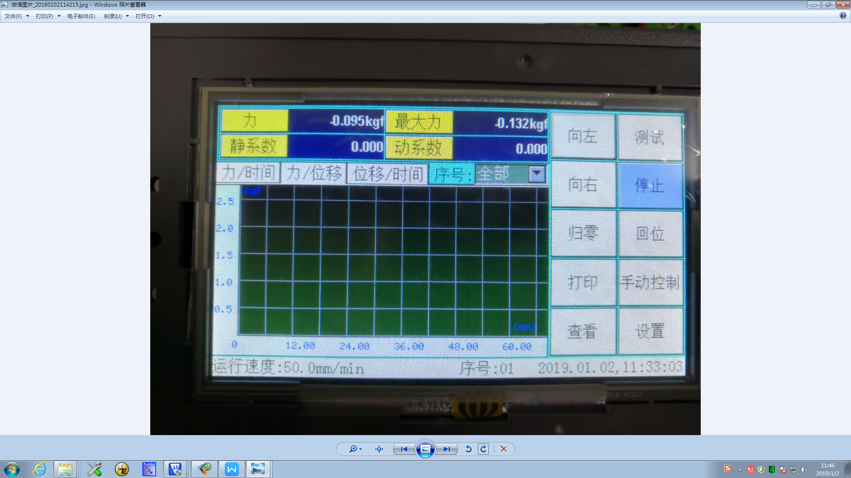

Button response when testing the interface:
Button "Left": controls the machine to move to the left;
Button "to the right": controls the machine to move to the right;
Button "test": execute the test;
Button "Stop": Click this button during the ascending and descending process to stop the machine. Click this button to end the test during the test;
Button "return to zero": zero the force, maximum force, displacement, deformation, etc.;
Button “Return”: Return the machine to the position where the “Return to Zero” button was pressed last time. You can press the “Stop” button to stop at any time during the return process, and press the “Return” button again to continue the return position; Press the “Return to Zero” button to stop, but press the “Return to Zero” button to stop and then press the “Return” button will not return again, because the program judges that the return position is completed when the “Return to Zero” button is pressed, so The machine stops no longer returning;
Button "Print Group": prints the current group data;
Button "Manual Control": Open the jog control and the lifting speed setting panel, as shown below;
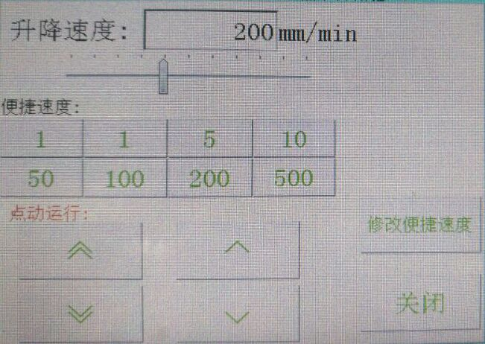
Button ""︽ ": Inching high speed rise, press and hold the machine to rise quickly, release the machine to stop, this speed can be set in the "Test Plan - Control Parameter 2" in the jog speed;
Button " ︾ ": Inching high speed drop, hold down the machine and quickly drop, release the machine to stop, this speed can be set in the "Test Plan - Control Parameter 2" in the jog speed;
Button “ ︿ ”: Inching low speed rise, hold down and slow down the machine, release the machine to stop, this speed can be set in the low speed of “In Test Plan – Control Parameter 2”;
Button “ ﹀ ”: Inching low speed down, hold down and slow down the machine, release the machine to stop, this speed can be set in the low speed of “Intesting Program – Control Parameter 2”;
Button "Modify convenient speed": set convenient speed;
Button "View": Enter the test result viewing interface;
Button "Settings": Enter the pre-test sample information and test method setting interface;

5.2 test plan
5.2.1 Test methods
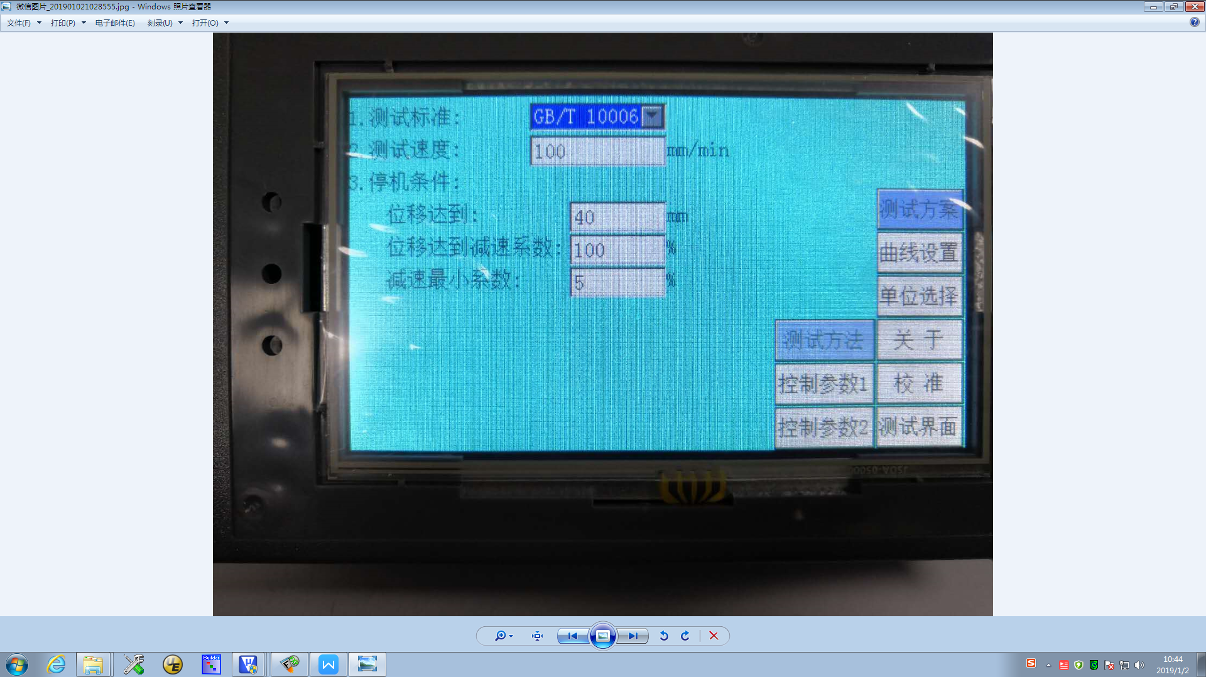
1. Test standard: set test standards;
2. Test direction: set the speed of the test;
3. Shutdown conditions:
When the stop condition is “deformation reached”: when the deformation reaches the value of 50mm, the deformation is 50mm during the test. The deformation reaches the deceleration coefficient: when the deformation value reaches the set deformation value multiplied by this coefficient, the deceleration starts (100). % is not reduced), the minimum coefficient of deceleration: when the deceleration speed reaches the maximum speed multiplied by this coefficient, stop deceleration, (if the maximum speed multiplied by this coefficient is greater than or equal to the test speed, it will decelerate at the test speed, equivalent to no deceleration );
5.2.2 Control parameters 1
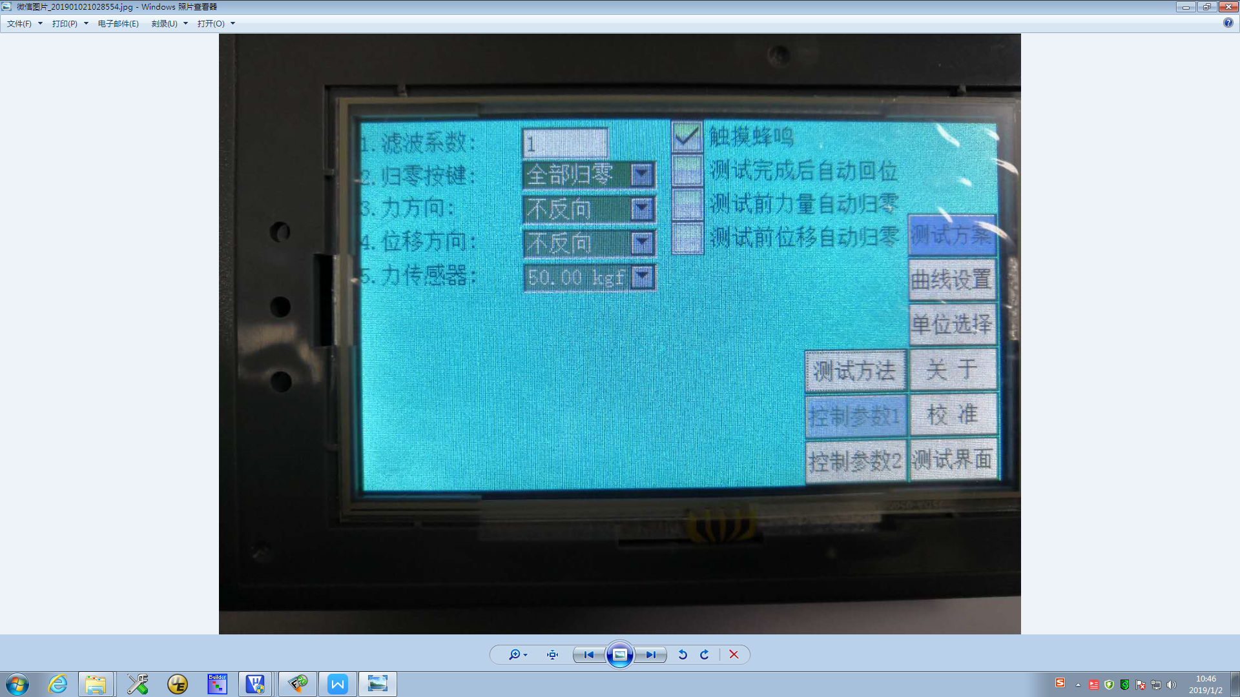
1. Filter coefficient: set the value of the filter coefficient, the range is 1-50, this value is the sensitivity of the current force value setting;
2. Zero button: Select the mode of the “Return to Zero” button on the main interface of the test. There are “all zeros” and “force return to zero” is optional.
3. Force direction: change the direction of force value, there are “reverse”, “not reverse”, “absolute value” is optional;
4. Displacement direction: change the direction of displacement value, there are “reverse”, “not reverse”, “absolute value” is optional;
5. Force sensor: select the channel of the force sensor;

5.2.3 Control parameters 2
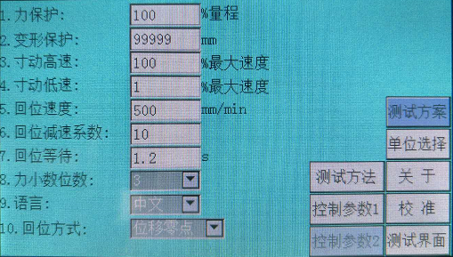

1. Force protection: set force value protection;
2. Deformation protection: set deformation protection paper;
3. Inch high speed: set the speed of the test main interface "inching high speed";
4. Inching low speed: set the speed of the test main interface "inch low speed";
5. Return speed: set the return speed;
6. Return speed reduction coefficient: When returning, when the stroke is less than the set value, it will start automatic deceleration to prevent displacement overshoot;
7. Return to wait: set the waiting time before returning to the position;
8. Force decimal places: Set the number of digits displayed after the decimal point of the force value;
9. Language: Switch language display, there are "English", "Chinese" is optional;
10. Return mode: Select the return mode, there is "displacement zero", "extreme position" is optional.

5.4 Curve setting
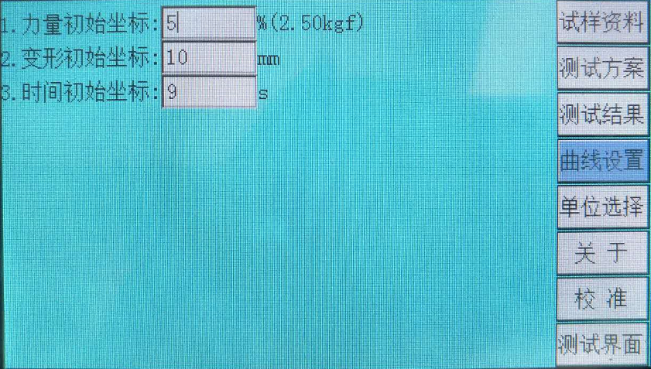
Set the curve coordinates.

5.5 unit selection
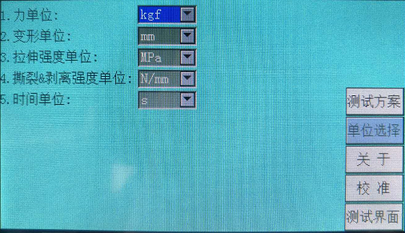
1. Force unit: The unit of switching force value, there are "kgf", "N", "lbf", "gf", "KN", "t" optional;
2. Deformation unit: switch the deformation unit, there are "mm", "cm", "in" optional;
3. Tensile strength unit: switch tensile strength unit; there are: MPa, kPa, kgf/mm2, kgf/cm2, N/mm2, N/cm2, N/m2, gf/mm2, gf/cm2, psi, ldf /in2, etc.
4. Tear & Peel Strength Unit: The unit of tensile strength is changed: N/mm, N/cm, N/m, kN/m, kgf/mm, kgf/cm, kgf/m, gf/mm, gf /cm, lbf/in, klbf/in, etc.;
5. Time unit: switch the deformation unit, with "s", "min", "H" optional;

5.6 About
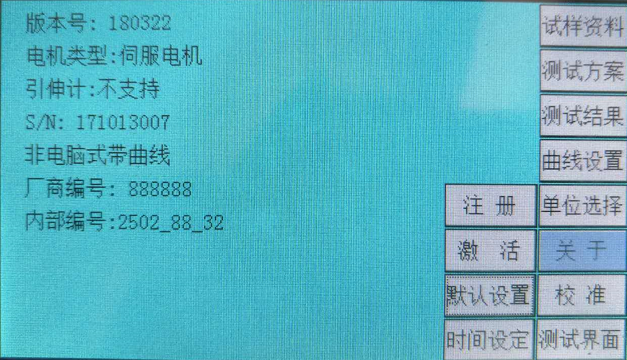
View version information

5.6.1 Registration

When the system fails to test, you need to provide the "manufacturer number" in the version information. The "serial number" asks the manufacturer for the registration code to register and unlock. How to set the service period will be explained in detail in the calibration advanced settings;

5.6.2 Activation

The system supports upgrading with a computer software system, the specific operation is to provide the serial number in the version information to the manufacturer to request the activation code to activate into the corresponding professional version of the computer software system;
5.6.3 Default Settings
Restore all parameters of the setup interface to the default factory settings. This item does not support recovery of the data in the calibration;

5.6.4 Time setting

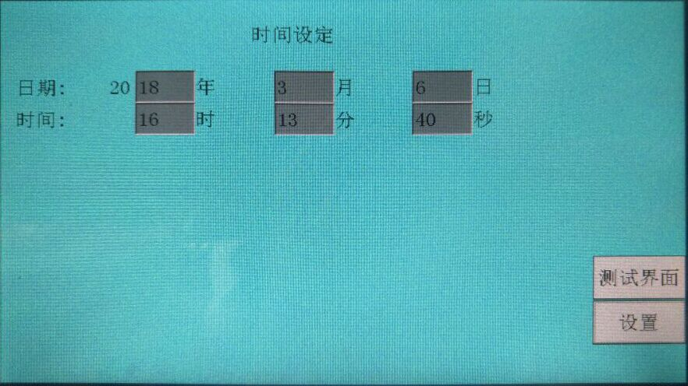
Set the system time.

5.7 View
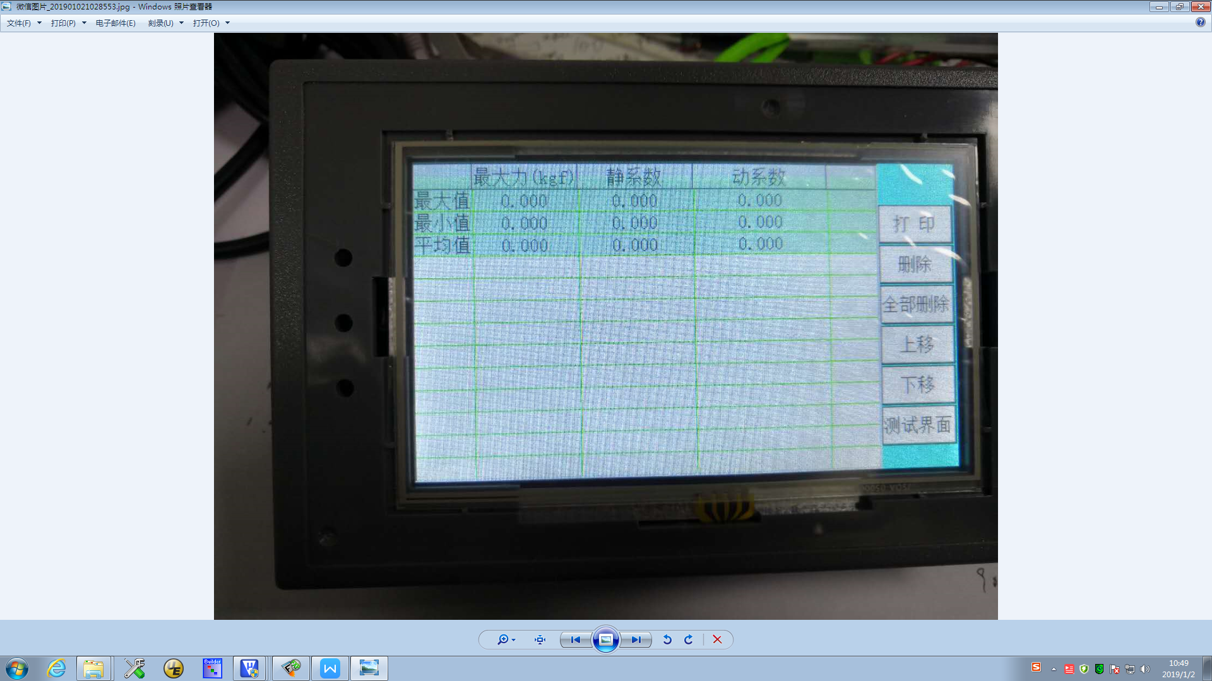
Button "Print": prints all the results currently viewed;
Button "take point window": open to view the manual point picking window;
Button "Move up": Select a group of test results to move up;
Button "Move Down": Select a group of test results to move down;
Button "Delete": delete the selected test result;
Button "Delete All": delete all test results;
Button "Test Interface": Return to the test main page;
The printed result is as follows:
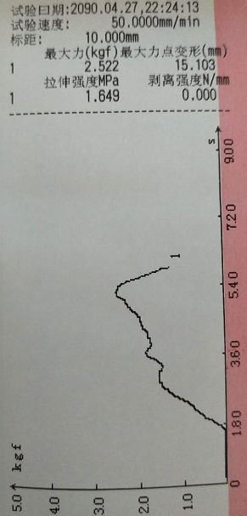
6. Calibration
6.1 force sensor
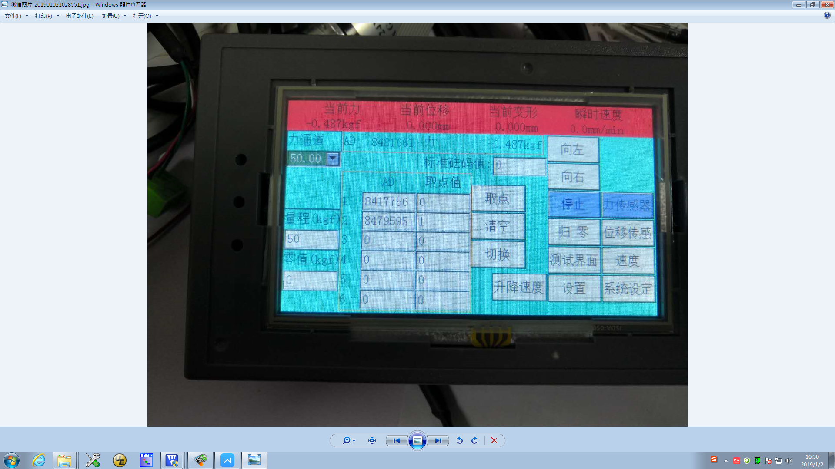
1. After selecting the channel to be calibrated in the upper left corner, the first step must be to calibrate the “zero point”. First click the “clear” button to clear the data in the calibration data table, then click the “force zero” button and make the force sensor Do not bear any load, and then press the "take point" button, the first point "zero point" is calibrated;
2. At this time, put the weight on the force sensor and set the “standard weight value” in the second row and second column of the “Calibration Data Table” to the weight of the weight (in kg). After the weight is stable, press the “take point” button to calibrate the second point;
3. Similarly, recalibrate the following points, or just calibrate 2 points;
4. Click the “force return to zero button”, then put the weight on the sensor. After the weight is stable, see if the “current force” value is equal to the weight of the weight. If they are equal, click the “Set” button to return. The main interface of the test is calibrated, otherwise 1-3 steps are repeated until the value of "current force" is equal to the weight of the placed weight.
Note: If the calibration exceeds 2 points, the weight of the weight added during the calibration process must be increased in turn, and the AD value displayed on the top line of the screen during the weighting process must also be increased. If the weight is found, AD If the value is decreasing, the wiring of the two signal lines of the force sensor needs to be exchanged; if only 2 points are calibrated, there is no such limitation.
In addition, it is better to record the calibration data (the data in the calibration table in the above figure) for the calibrated machine, so that if the calibration data is modified by mistake during the subsequent use, simply re-enter the recorded data. It can be restored to normal without re-calibration with a weight or calibrator.

6.2 displacement sensor
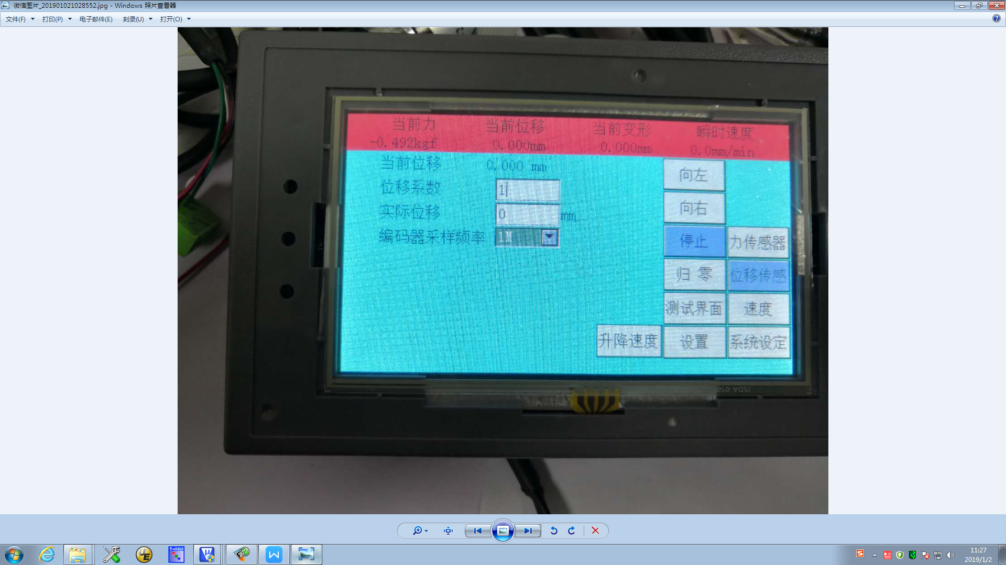
1. Click the “Shift to Zero” button to reset the “Current Displacement” to zero;
2. Click the “Rise” or “Down” button to let the machine walk a certain distance and measure the distance with a ruler. 3. Enter the measured data into the box after “Actual Displacement”:
4. Repeat steps 1-2 to check whether the machine stroke value is equal to the current displacement value displayed by the software. If they are equal, complete the displacement sensor calibration, and vice versa.
5. Repeat steps 1-3 until the value of the machine travel is equal to the value of Current Displacement.

6.3 speed
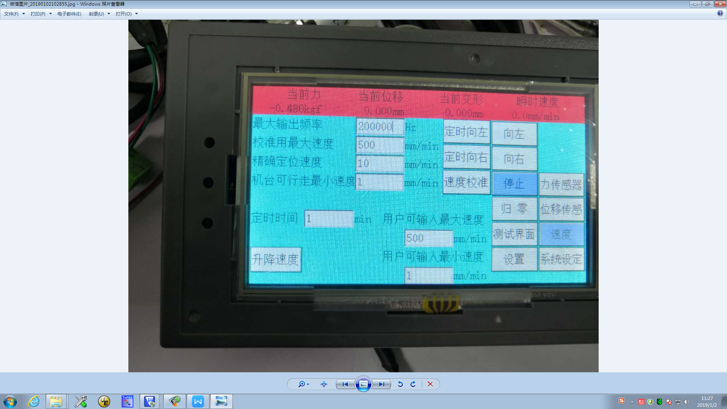
Calibrate the displacement sensor before calibrating the machine speed. If there is no calibration displacement, the speed is not correct.
Button "lifting speed": modify the speed of "up" and "down" in the calibration, as shown below;
1. Under the premise that the displacement is calibrated, in the current tab control panel section, the default value of “Maximum speed for calibration” is given by default, and the button “all zeros” is clicked;
2. Then adjust the speed bar or directly enter the "debug speed" to give the machine a speed;
3. Click the button "up" or "down" to let the machine walk for a distance and click the "stop" button to stop the machine;
4. Then click the button “Speed Calibration”. After clicking this button, the value of “Maximum Speed for Calibration” will change and the speed calibration will be completed.
5. Repeat steps 1-4 until the speed is accurate.

- Installation of test machine (Figure 1)

As a kind of sophisticated testing equipment, the friction coefficient tester has certain requirements for installation, adjustment and working environment to ensure the accuracy of the test results and the normal operation of the testing machine.
5.1 Before unpacking, users should first check whether the package is in good condition. After opening the package, check the test machine and accessories for completeness and damage after checking the packing list.
5.2 Place the test machine on a sturdy platform and adjust the adjustment nut under the frame so that the horizontal bubble on the frame is in the middle position. 5.3 Insert the power cord of the testing machine into the three-pin socket of the indoor power supply system, and turn on the power switch to test.
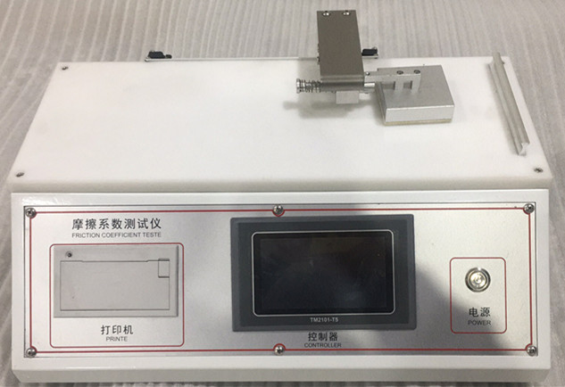
（figure 1）
8. Use and operation
The basic operation steps of the friction coefficient tester are as follows:
Determination of film (sheet) to film (sheet)
6.1 The test surface of a specimen is lifted up and flat on a horizontal test bench. The length of the sample and the test bench should be parallel.
6.2 Lower the test surface of the other specimen, wrap the slider, and fix the pattern on the front and upper surfaces of the slider with tape.
6.3 Place the fixed-type slider in the center of the first specimen without impact, and make the test direction of the two specimens parallel to the direction of the slider and the force measurement system is not affected by the force.
The first peak of the 6.4 force is the static friction force Fs. The average value of the force within 60 mm of relative movement (excluding static friction) is the dynamic friction force Fd.
6.5 If the force value oscillates after the static friction force, the dynamic friction force cannot be measured. In this case, the spring between the slider and the load cell should be removed and the dynamic friction force measured separately. This measurement is not suitable for static friction due to inertia error.
6. 6 Determination of film (sheet) for other materials
When measuring the frictional properties of plastic film (sheet) on the surface of other materials, the plastic film (sheet) should be fixed on the slider, and the samples of other materials should be fixed on the horizontal test bench, and the other steps are the same as above.
6.7 Test Turn on the power switch on the rack control board and press the “Test” button to enter the display interface. Press the “Test” button again to test. The test can be automatically stopped in 38 seconds. During the test, the test machine automatically displays the force value curve and calculates the result. Press the “Return” button to return to the original position. To print, press the “Print” button. If the test piece is subjected to the second test, the procedure is the same as above.
6.6 Shutdown After the test is finished, turn off the power.
9. maintenance
In order to keep the friction coefficient tester in good working condition and have a long service life, the test machine must be regularly maintained.
7.1 Before each test, the test piece shall be prepared according to the standard requirements and then installed on the workbench.
7.2 When replacing the sample, the load cell is very sensitive. Do not touch it, otherwise it will cause damage.
7.3 After the test is finished, the test machine should be wiped clean and placed for the next use. 7.4 When the test machine is not used for a long time, it should be regularly injected with a proper amount of lubricating oil at the rotating part to ensure the good working condition of the machine.

