Content
1 General Introduction 3
2 Work Principle 4
3 Name of each components 5
5. Operational Measure 7
5.1 Measurement preparation 7
5.2 Switch on、Switch off 8
5.3 Selecting Parameter 8
5.4 Measuring 9
5.5 Calibration 10
5.6 Battery Recharge 11
6. Daily Maintenance 11
6.1 Maintenance 11
6.2 Repair 12
7.Terminology Definition 12
8.User Notes 15

1 General Introduction
The product is a new portable Surface Roughness Tester developed by our company.Featuring high accuracy,wide range of application, simpleoperation and stable performance. It is widely applicable in testing surfaces of all kinds of metals and non-metals. Integrating pick up with the main unit, it is a hand-held set, especially suitable for use on production sites.
- Appearance using pull aluminum mould design, durable,anti-electromagnetism interference ability significant, accord with current design new trend.
- By using high-speed DSP processors for the data processing and calculation, measuring and calculation speed is greatly improved.
- Display is the use of popular OLED module, high brightness, no perspective, wide temperature.It is suitable for various applications.
- Using lithium ion rechargeable batteries, it can work long hours with no memory effect.It also can work with charging .Charging time is short,while the battery life is long.
- Use the common USB interface to charge and communication .Use special charger or the computer USB port of chargeIt’s convenient and quick.
- Dot matrix OLED display, interface message is rich.
- Real-time monitoring of lithium battery power and display, electric charge and timely remind users.
- Automatic shutdown function,low power consumption and hardware design make instrument working hours exceeds.It is suitable for all kinds of field use.
- The sensors head has the protect door,which protect the head of the sensors effectively. Guarantee the accuracy of measurement.

2 Work Principle
When the pickup driven by a driver is making a linear uniform motion along the test surface,the contact stylus in perpendicular with the work surface is moving up and down on the work surface.Its motion is converted into electric signals, which are amplified, filtered and transformed into digital signals through A/D. The signals are then processed by the DSP into Ra and Rz values before displayed on the screen.

3 Name of each components
4. Technical Parameters
- Measurement Parameters(µm)：Ra Rz Rq Rt
- Stroke Length（mm）：6
- Sampling Length（mm）：0.25 ，0.80 ，2.50
- Evaluation Length（mm）：1.25 ，4.0 ，
- Measurement Range（µm ）：
Ra,Rq： 0.05 ~ 15.0
Rz,Rt： 0.1 ~ 50
- Error of Indication：±15%
- Varation of Indication： ＜12%
- Touch needle tip arc radius and angle of the sensor
Tip arc radius：10 µm±1 µm
Angle：90${}_{−\text{10}°}^{+5°}$
- The sensor touch needle static force measurement and its rate
Touch needle static force measurement： ≤ 0.016N
Force measurement rate： ≤ 800N/m
- Sensor guide head pressure： ≤ 0.5N
- Battery:3.7V Lithium Ion battery
- Contour Dimension：106 mm×70 mm×24 mm
- Weight：200g
- Working Environment Conditions
Temperature： -20℃～40℃
Relative Humidity： < 90%
Surrounding no vibration and no corrosive medium.

5. Operational Measure

5.1 Measurement preparation
Remove instrument, right now the sensors head protect door should be closed.( see illustration below)

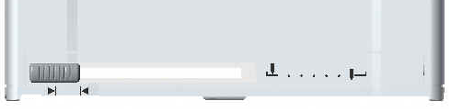

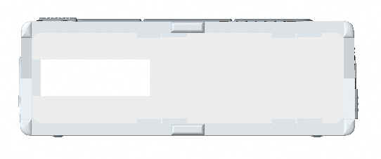

To the right to promote measuring head protect door switch, Open the sensors head protect door, Show the sensors head prepare measurement.

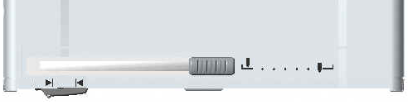

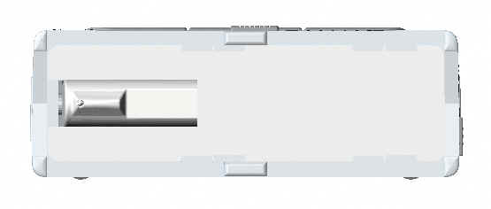

5.2 Switch on、Switch off
Button  a second boot,after a voice of di,going into measurement state.Mearsuring parameters and sampling length will keep the last time before the shutdown of the state.
Boot condition , buttons a second shutdown. The instrument will go into the low consumption status. In 3 minutes，without buttoning,the operating instruments will be turned off.

5.3 Selecting Parameter
Beforing mensuring the user should set up these parameters such as Ra Rz Rq Rt，and the appropriate sampling length and male imperial.
Touch 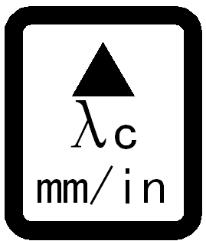 keys, chosing sampling length 0.25mm、0.8mm、2.5mm
Long press 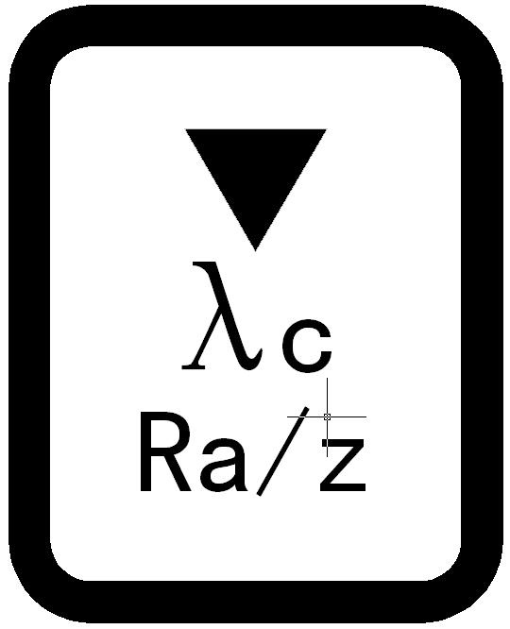 key 2 seconds will clavier for etric/imperial conversion。
Touch 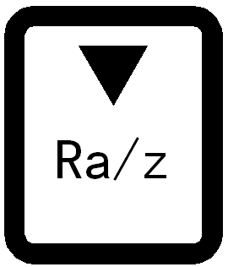 keys,chose the measurement parameters Ra、Rz Rq Rt.

5.4 Measuring
When the parameters are set up and the cut-off samples length is decided,it will come to measurement.Point the Stylus markto the measured area stably and then press the Start Key on the top to start measurement, liquid crystal display as “Waiting”.At this time ,it will be invailid to press the start button.
After the “Waiting”disappeared with two“d.d”，the measurement has being finished,and the screen will show the measured value.
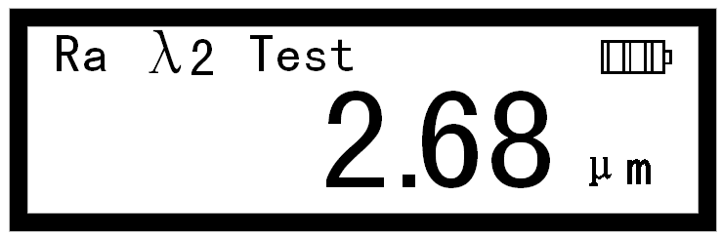
Note:
- During the pickup’s travel,do your best to make sure the tester is on the measured surface stably so as to avoid its influence to the precision.
- During the pickup return to its previous position,the tester will not make any response to further operation.
- If the tester has be dying,you must press the Reset Key ,and then you can use it again.

5.5 Calibration
Before use,calibration should be done with the standard sample plate.For example,there is a standard sample plate pointed to 3.14.
In shutdown condition, Press the start button boots, As shown below ,release the start button.The tester will enter the status of Calibration.

Press the Up Key and Down Key to adjust the displaying value to the value3.14.
Put the instrument in the scribed line area.Sensor taxiing direction perpendicular to the scribed line of texture direction.Press the Start Key to exit the status of Calibration. Repeated many times calibration could evidently improve precision.
After measuring,the new standard sample plate value will be stored to the memory instead of the old one.At the meantime, shutdown and restore,the instrument start work normally.
If the user has multi-reticle sample plate,he can choose suitable sample plate to calibrate the tester against his measuring range in common use.By this way,the tester’s precision can be improved greatly.

5.6 Battery Recharge
Plug the charger into the tester’s recharge socket and have the tester  recharged together with the battery symbol lighting (if no lighting,plug it again).3hours recharging-time is enough. Filled animation end.
Even in shutdown condition may also start charging interface display.

6. Daily Maintenance

6.1 Maintenance
  - Protect the tester from collision,violent shock，heavy dust,dampness,oil stain,and strong magnetic field etc.
  - Please switch off in time after each measurement to save the energy,and have the battery recharged promptly when necessary.
  - The sensor is the precision part of the tester and particular care should be take off it.After each use,put on the protective sheath gentle so far to avoid violent shock to the sensor.
  - Standard sample plate provided with the tester should be given special protection to avoid scratch that may make the calibration inaccurate.

6.2 Repair
If any trouble occurs, user should not try to dismantle and repair it. The device should be returned to the manufacturer for checking and repair, together with the warranty card and the specimen provided and a statement about the trouble .Please keep in constant touch with the marketing department of our company or our sales agents.

7.Terminology Definition
- Surface Roughness is the microcosmic geometric form on the work-piece surface composed by peak and valley with small interspaces.
- Sample Length is the benchmark’s length used to be distinguished its surface roughness.
- Evaluation Length is the necessary length for evaluating the roughness profile.It may include one or more sampling lengths.
- Ra: Airthmetical Mean Deviation of the Profile is arithmetic mean value of the deviation of the profile within sampling length.
- Rz: The maximum Height of Irregularities is the distance between maximum depth of the profile peaks and maximum depth of the profile valley within the sampling length.
- Rq: Root-mean-square Deviation of Profile
Rq is the square root of the arithmetic mean of the squares of profile deviation (Yi)from mean within sampling length.
- Rt:Total Peak-to-valley Height
Rt is the sum of the height of the highest peak and the depth of the deepest valley over the evaluation length.
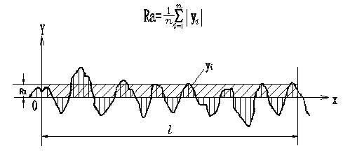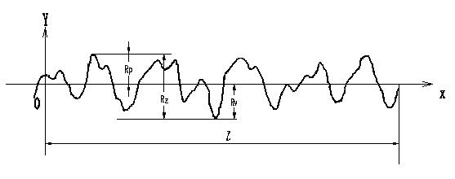
$$\text{Rq}={\left(\frac{1}{n}\sum_{i=1}^{n}{y_{i^{2}}}\right)}^{\frac{1}{2}}$$

8.User Notes
- Users buy our products, Please fill in < warranty card>and afixed to the user unit seal.After that, Put them and invoice copy to send to the company. You can also entrust sale machine unit with send. If the formalities isn’t full, only maintenance cannot guarantee.
- From the date of purchasing this company’s products, occur quality faults in a year, please keep in constant touch with the marketing department of our company with the warranty card or invoice copy.You can repair the product for free. Under warranty,if you cannot produce warranty card or invoice, according to the production date calculation guarantee, term is one year.
- Over warranty,if the products have any trouble,we will collect upkeep according to company rules.
- If the user disassemble this company product or improper safekeeping of transportation or not products according to the instruction for use correct operation damaged products, and alter guarantee card, no merchandising vouchers, this company shall not be warranty.
- Non-warranty Parts
Sheak,Pickup,Battery,Charger,communication cable

